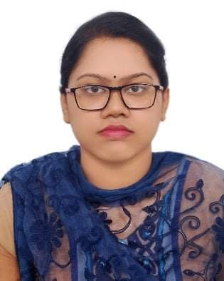

**Chandra Saha Esha**

**Address: 272-khq/3-D,Agargaon,.**

**Dhaka-1207**

**Cell**: 01972098675

Email: eshachandrasaha@gmail.com

**Career Objective**

Perform to work under a well reputed organization that runs with the modern management systems. I would like to devote myself proving the best capabilities and sincerities under any condition at any cost.

**Educational Attainment:**

* **Bachelor Of Science (B.Sc):**

Institute : International University of scholars

Department : Computer Science Engineering (CSE)

Passing : Running

* **Diploma in Engineering :**

Institute : Dhaka Mohila Polytechnic institute

Board : BTEB

Group : Computer Science & Engineering

Result : GPA-3.12 (out of 4)

Passing Year : 2020

* **Secondary School Certificate (S.S.C):**

Institute : Kapasia Technical School

Board : Dhaka

Group : Science

Result : GPA-4.86 (out of 5)

Passing Year : 2016

**Job Experience:**

* Origination Name : Creative IT Institute

Position : Internship

Duration : 3 Months

Responsibilities : Graphic design

**Language Proficiency:**

* Bengali (Mother Tongue, both written and spoken)
* English (Good Writing and Speaking Ability)

**Computer Skills:**

Ms.Office Application (MS Word, Excel, PowerPoint)

Adobe Photoshop, Adobe Illustator Internet Browsing Etc.

**Interest & Hobbies:**

Hard working & Good in Human relation work, reading, writing, travelling, specially sports, social work, News Reader.

**Personal Profile**

Name : Chandra Saha Esha

Father’s Name : Chitto Ronjon Saha

Mother’s Name : Bina Saha

Date of Birth : 15thJanuary2000

Permanent Address : Vill- Kapasia, P.O- Kapasia,

P.S- Kapasia, Dist- Gazipur.

Present Address : 272-kha/3-D, Agargaon

, Dhaka-1207.

Religion : Hindu

Sex : Female

Height : 5' 07"

Blood Group : B+

Marital Status : Unmarried

Nationality : Bangladeshi (By Birth)

|  |  |
| --- | --- |
|  |  |
|  |  |
|  |  |

Signature

Esha

(Chandra Saha Esha)